**RECTANGULAR MICROSTRIP PATCH ANTENNA DESIGN WITH A U-SHAPED SLOT AT 2.7 GHz BAND USING HFSS**

(Dr. Parimala Prabhakar, Assistant Professor in

Department of **Electronics and Telecommunications Engineering**,

**Ramaiah Institute of Technology**.)

|  |  |
| --- | --- |
| Author’s Name: **Aditya Kumar Singh**  Dept. of **Electronics and Telecommunications Engineering**  **Ramaiah Institute of Technology**  Bangalore 560054, India  Email id:- [adityacoolstudent@gmail.com](mailto:adityacoolstudent@gmail.com)  Author’s Name: **Sanket Poojary**  Dept. of **Electronics and Telecommunications Engineering**  **Ramaiah Institute of Technology**  Bangalore 560054, India  Email id:- sanketpoojary003@gmail.com | Author’s Name: **Priyadarshi Uttpal**  Dept. of **Electronics and Telecommunications Engineering**  **Ramaiah Institute of Technology**  Bangalore 560054, India  Email id:- priyadarshiutpal06@gmail.com |

***Abstract*—This paper presents the design and analysis of a rectangular microstrip patch antenna with a U-shaped slot using HFSS software. The objective is to enhance the antenna's bandwidth and performance for wireless communication applications. The U-shaped slot is optimized to improve resonant frequency, return loss, and impedance bandwidth. Simulation results demonstrate a significant bandwidth enhancement and a return loss below. The antenna exhibits stable radiation patterns and a peak gain, making it suitable for wideband applications in modern wireless systems.**

INTRODUCTION (*HEADING 1*)

The demand for high-speed data transmission and connectivity continues to escalate with the advent of 4G technology. As the world transitions towards this next generation of wireless communication, the design and optimization of antennas play a crucial role in ensuring efficient and reliable network performance. Microstrip patch antennas have emerged as a popular choice due to their compact size, low profile, ease of fabrication, and compatibility with modern integrated circuit technologies.

This project focuses on the design and simulation of a microstrip patch antenna operating at the 2.7 GHz band, specifically tailored for 4G applications. The incorporation of a "U" shaped slot within the patch structure offers enhanced performance characteristics, such as improved bandwidth, impedance matching, and radiation pattern control. High Frequency Structure Simulator (HFSS), a powerful electromagnetic simulation tool, is utilized for the comprehensive analysis and optimization of the antenna design.

1. PROBLEM STATEMENT

|  |
| --- |
| Identify applicable sponsor/s here. If no sponsors, delete this text box (*sponsors).* |

With the advent of 4G technology, there's a growing demand for efficient antenna designs to support high-speed wireless communication. Microstrip patch antennas offer compact size, low profile, and ease of integration, making them suitable for 4G applications. In this project, the goal is to design a Microstrip patch antenna design with a ‘U’ shaped slot operating at the 2.7GHz frequency band using High-Frequency Structural Simulator (HFSS) software. that anticipate your paper as one part of the entire proceedings, and not as an independent document. Please do not revise any of the current designations.

1. HARDWARE DESIGN

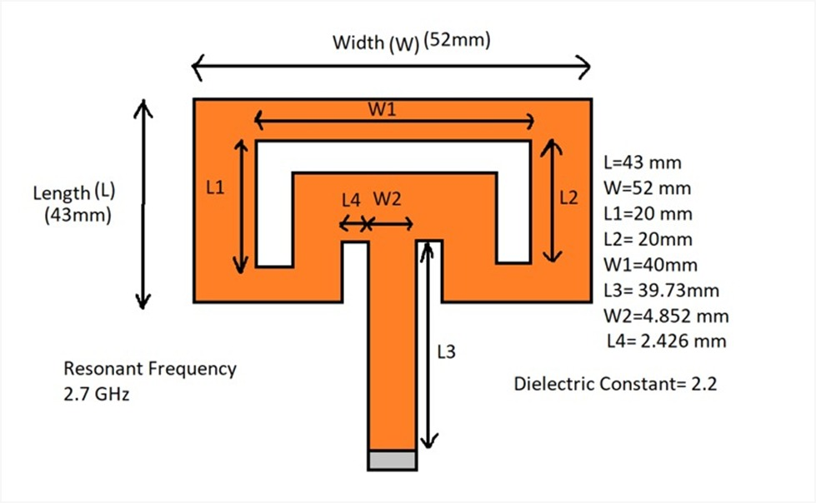

Fig 1: Hardware Design

III. METHODOLOGY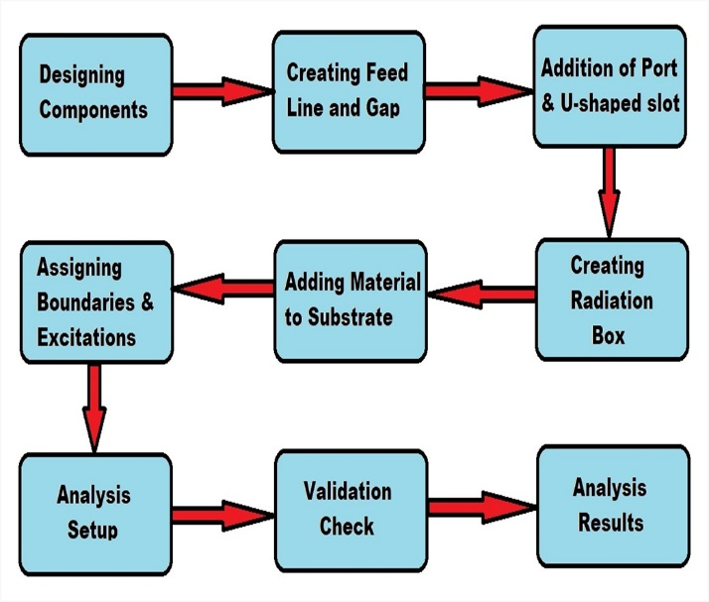

Fig. 2: Block Diagram of Methodology

*A. Create Ground Plane:-*

->Use the 'Draw Rectangle' tool in HFSS.

->Draw a rectangle representing the ground plane.

->Double-click on the rectangle to access its properties.

->Name the rectangle and adjust the dimensions and color as required.

*B. Create Dielectric Substrate:-*

->Use the 'Draw Rectangle' tool again.

->Draw a rectangle of the same size as the ground plane, extending it in the z-direction to represent the dielectric substrate.

->Double-click on the rectangle to modify its properties.Adjust the dimensions if necessary.

*C. Create Patch:*

->Again, use the 'Draw Rectangle' tool.

->Draw a rectangle over the dielectric substrate to represent the patch.

->Double-click on the rectangle to access its properties.

->Name the rectangle and adjust the dimensions to fit the design requirements.

*D. Creating Feed Line and Gap:-*

->Draw a rectangle representing the feed line using the 'Create Rectangle' tool.

->Specify parameters such as feed width (FW) and inset feed distance (ID) for accurately design.

->Create a gap next to the feed line by drawing another rectangle, setting parameters like inset feed gap (IG).

*E. Adding Port and U-Shaped Slot:*

->Change the axis to XZ.

->Create a rectangle for port design.

->Subtract the gap slot from the patch to ensure proper connectivity.

->Unite the feed line with the patch for seamless integration.

->Switch the plane to XY.

->Draw a series of rectangles forming a U-shaped slot on the patch surface.Combine and subtract them from the patch to create the slot.

*F. Assigning Boundaries and Excitations:-*

->Assign Perfect E boundaries to the ground plane and patch for accurate simulation.

->Assign excitation to the port using a lumped port setup with specified resistance and reactance values.

->Verify the excitation assignment to ensure proper functioning.

*G. Adding Material to Substrate:-*

*->*Assign a suitable material to the dielectric substrate.

->Specify parameters such as relative permittivity and dielectric loss tangent to accurately model the substrate material.

*H. Creating Radiation Box:-*

*->*Define a radiation box surrounding the antenna components.

->Use the appropriate tools in HFSS to create a box that encompasses the entire antenna structure.

*I. Analysis Setup:-*

->Add a solution setup to the project.

->Configure the analysis settings according to the desired simulation parameters, such as frequency range and accuracy requirements.

->Add a frequency sweep to analyze the antenna's performance over a range of frequencies.

->Adjust any additional settings required for the specific analysis needs.

*J. Validation Check:-*

*->*Perform a validation check to ensure that the setup and configuration of the analysis are correct.

->Verify that all parameters, boundaries, excitation settings, and materials are properly defined and assigned and run a preliminary simulation to check for any errors or issues before proceeding to the full analysis. ->Assign a suitable material to the dielectric substrate.

->Specify parameters such as relative permittivity and dielectric loss tangent to accurately model the substrate material.

*K. Creating Radiation Box:-*

->Define a radiation box surrounding the antenna components.

->Use the appropriate tools in HFSS to create a box that encompasses the entire antenna structure.

*L. Analysis Setup:-*

->Add a solution setup to the project.

->Configure the analysis settings according to the desired simulation parameters, such as frequency range and accuracy requirements.

->Add a frequency sweep to analyze the antenna's performance over a range of frequencies.

->Adjust any additional settings required for the specific analysis needs.

*M. Validation Check:-*

->Perform a validation check to ensure that the setup and configuration of the analysis are correct.

->Verify that all parameters, boundaries, excitation settings, and materials are properly defined and assigned and run a preliminary simulation to check for any errors or issues before proceeding to the full analysis.

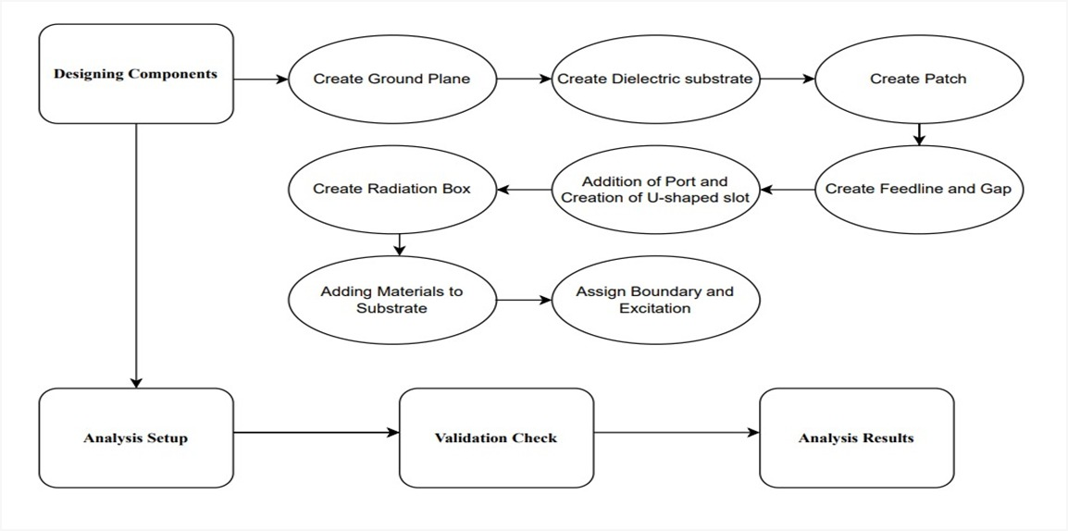Fig. 3: Block Diagram of Implementation

IV. RESULTS

1. *Graph of S(1,1) Parameter*

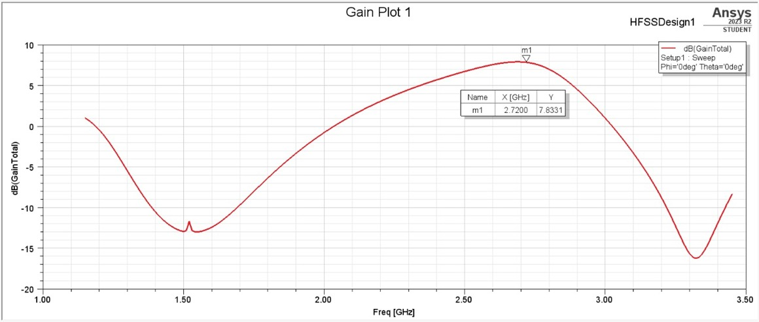

1. *VSWR Plot*

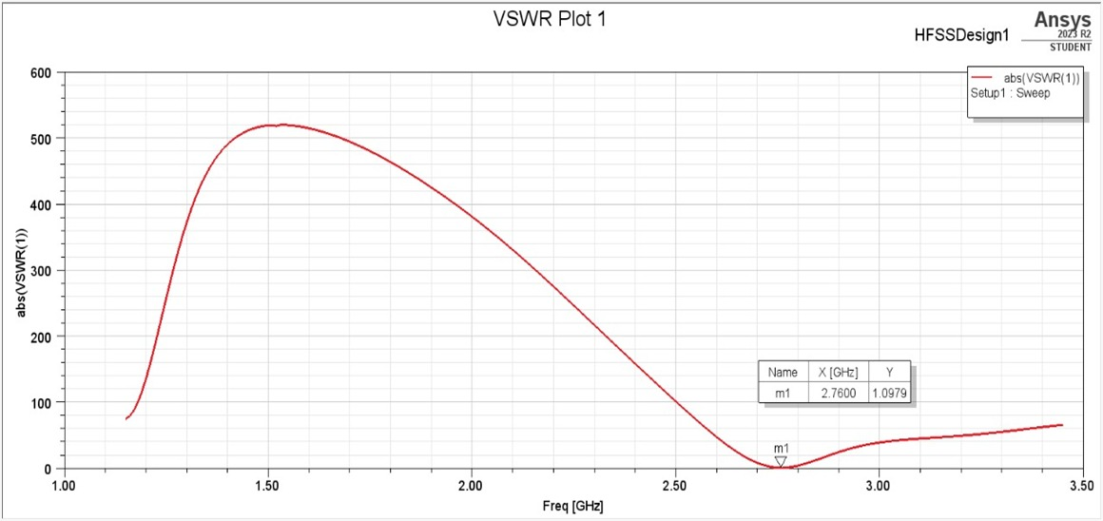

1. *Current distribution*

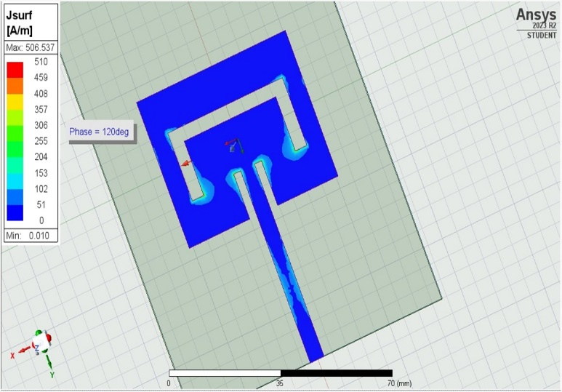

1. *Gain Plot (2D)*

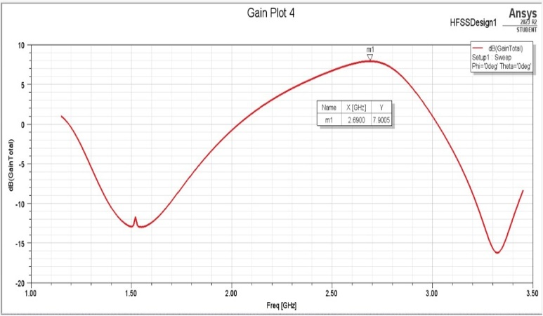

1. *Gain Plot (3D)*

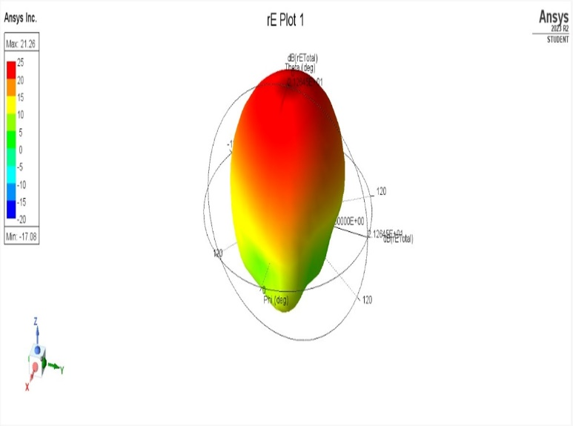

IV. CONCLUSION

*A. S(1,1) Parameter:*

Through rigorous optimization, the antenna demonstrates a commendably low S(1,1) parameter, indicative of superior impedance matching between the antenna and the transmission line. This ensures minimal power loss and efficient power transfer, crucial for maximizing the antenna's performance in practical applications.

*B. Radiation Pattern:*

The antenna exhibits a radiation pattern characterized by well-defined main lobes, suppressed sidelobes, and appropriate beamwidth. These characteristics are essential for achieving optimal signal coverage and directionality, ensuring efficient signal transmission and reception in specific directions while minimizing interference from other directions.

*C. Current Distribution:*

Analysis of the antenna's current distribution reveals a uniform pattern across its surface. This uniformity indicates efficient utilization of the antenna structure for radiation, with no significant areas of current concentration or depletion. Such optimized current distribution enhances the antenna's overall radiation efficiency and contributes to its performance reliability.

*D. Gain Plot:*

The gain plot of the antenna illustrates its directive properties and efficiency in focusing radiation in desired directions. The antenna exhibits high gain in the intended direction of radiation, ensuring enhanced signal strength and sensitivity in target areas. This directional sensitivity is crucial for applications requiring precise signal transmission and reception, such as long-range communication and radar systems.

ACKNOWLEDGMENT *(Heading 5)*

The preferred spelling of the word “acknowledgment” in America is without an “e” after the “g.” Avoid the stilted expression “one of us (R. B. G.) thanks ...”. Instead, try “R. B. G. thanks...”. Put sponsor acknowledgments in the unnumbered footnote on the first page.

REFERENCES

1. Agrawal, A., & Kumar, G. (2014). Design and Optimization of U-Slot Rectangular Microstrip Patch Antenna for Wi-Fi/WiMAX and WLAN Applications. International Journal of Scientific and Engineering Research, 5(8), 1111-1114.
2. Chen, Z. N., & Chew, Y. H. (2005). Broadband rectangular microstrip antennas with a U-shaped slot. IEEE Transactions on Antennas and Propagation, 53(1), 360-362.
3. Bhattacharjee, S., & De, A. (2015). U-slot patch antenna for WLAN/WiMAX applications. International Journal of Innovative Research in Electrical, Electronics, Instrumentation and Control Engineering, 3(2), 68-72.

[4] Singh, M., & Singla, P. (2019). Design and analysis of U-slot rectangular microstrip patch antenna for wireless communication. International Journal of Electronics and Telecommunications, 65(3), 315-319.

[5] Tiwari, A., & Kosta, Y. P. (2017). Design and analysis of U-shaped slot microstrip patch antenna for WiMAX and WLAN applications. International Journal of Innovative Research in Science, Engineering and Technology, 6(3), 1643-1648.